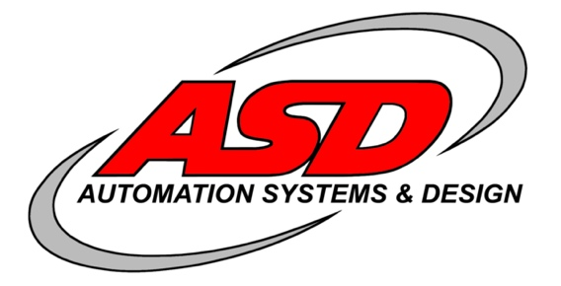
ASD is a professional organization of engineering
and technical personnel from a wide variety of
industrial backgrounds. The focus of the business is
to address the needs of the “Industrial Automation Market”.
OPEN POSITIONS

Welder
Machinist
Boring Mill Operator
CNC Machinist
Mechanical Designer
Assembler
Shipping/Receiving Clerk
Electrican
Services
- Consulting
- Material Handling
- Machine Tending
- Mechanical/Electrical Design
- Robotic Extraction
- Robotic Ladling

About Us
ASD provides equal employment opportunities (EEO) to all employees and applicants for employment without regard to race, color, religion, gender, sexual orientation, gender identity, national origin, age, disability, genetic information, marital status, or veteran status. If you are interested in any of these positions please email me directly.
.

QR Code
HR Contact Information
Sukhi Kullar | Vice Persident
sukhik@asddayton.com
(937) 387-0351

Articles Regarding the Dayton Area
US News & Report names six Ohio cities to the 2023-2024 Best Places to live in the US:

www.bit.ly/47ZK6gt

Forbes ranks 3 Ohio metro regions as Best Places for Young Professionals (Columbus & Cincinnati make the top 10): https://bit.ly/3Purpdl

What’s it like to live in Dayton, OH?
Dayton offers a downtown area full of unique activities and suburbs that provide close-knit communities for those who call the region home.
As the hometown of first flyers Orville and Wilbur Wright and the Wright-Patterson Air Force Base, this Ohio metro area is rich in aviation history. Aviation enthusiasts will appreciate the Dayton Aviation Heritage National Historical Park, the National Museum of the U.S. Air Force, and the Wright Brothers National Museum.
Those who enjoy spending time outdoors will find many metro parks and more than 350 miles of paved biking trails. Historic neighborhoods and districts, a bike-share program and several craft and microbreweries add to Dayton's appeal.
See all the best places to live in Ohio.
The Dayton region consistently tops national lists as one of the most affordable places to live in the country. It is the perfect place to find energy efficient, comfortable housing – whether you are looking for a large suburban home, condo in the city, or something in-between. There are historic districts and diverse neighborhoods throughout the region that are both friendly and convenient to buyers and renters alike.

Contacts:
Gwen Eberly, Montgomery County Economic Development & Planning Manager, Eberlyg@mcohio.org 937.776.3017
Lisa Robertson, Montgomery County Community & Economic Specialist, Robertsonl@mcohio.org 937.224.3850
M. Marie Davis, Dayton Development Coalition, Director, Talent Acquisition, mdavis@daytonregion.com 937.416.4442
Jocelin Dean, Dayton Development Coalition, Associate Talent Manager, jdean@daytonregion.com 937.416.3870
Why Dayton ?
Why Ohio ?
Why Ohio?

