The City of Dayton Ohio
Department of Water

Mad River Dam Project Description

Department of Water, Water Supply & Treatment Mad River Wellfield Background Information

The Division of Water Supply and Treatment is responsible for three wellfields, two treatment plants, and multiple pumping stations providing water to over 400,000 residents. The Mad River Wellfield supplies water to the Ottawa Treatment Plant, which has a daily capacity of 96 million gallons (MGD) per day. The Mad River Well Field consists of 70 gravel-packed wells ranging from 18 to 38 inches in diameter and from 50 to 205 feet in depth. The individual well capacities range from one to four MGD. Water discharged from the wells flows by gravity for three miles to the Ottawa Treatment Plant through pipes from 10 to 84 inches in diameter. Twenty-nine wells are in the Rohrers Island area; other well locations extend to the north and southwest along the Mad River. Artificial recharge from a series of excavated channels fed by the Mad River maintains the water table at Rohrers Island.
Mad River Dam Project Description

The Mad River Dam Project will replace a conversion dam built in 1935 on the Mad River east of downtown Dayton. The conversion dam diverts water from the Mad River to recharge lagoons located within the Rohrers Island area of the Mad River wellfield. The dam, approximately 10 feet tall and 260 feet long, is constructed with a rockfill structure, a concrete cap, concrete wing walls on each abutment, and steel sheet-piling on the upstream side.
The Mad River Wellfield is influenced by three Class IV dams around Rohrers Island: the conversion dam, the block dam, and the trapezoidal dam. The conversion dam is located approximately 3,000 feet downstream of Huffman Dam, a flood control dam operated by the Miami Conservancy District. The block dam is located 1.25 miles downstream from the conversion dam. The crest elevations of the conversion and block dams facilitate surface water flow into Rohrer’s Island and recharge of the wellfield. Between the conversion dam and block dam is an intake structure which the City uses to flood the wellfield and help recharge the groundwater aquifer. The trapezoidal dam, located downstream of the block dam, controls the flow of water back into the main channel of the Mad River.
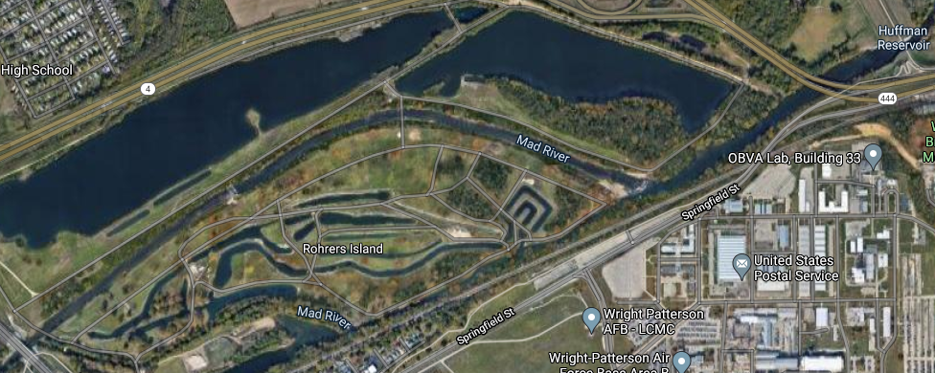
In the early eighties a section of the dam was repaired after a collapse. The repair included the addition of sheet-piling on the upstream side of the concrete dam, which raised the crest of the dam by one foot. After heavy rains the City’s well field staff push the riprap at the bottom of the dam back up and replace any washed out rip-rap to help maintain the dam. An inspection report from 1989 mentions spalling of the concrete wing walls that have deteriorated further since then. In 2009 city crews completed a large concrete repair at the east side of the dam adjacent to the abutment. In 2018 a center section of the dam collapsed, and emergency repairs were completed in 2021 by a contractor. During the repairs while a cofferdam was in place, a thorough inspection was completed revealing extensive undermining of the existing dam as well as severe concrete cracking. The inspection led to the determination that full dam replacement was appropriate rather than attempting a more repairs of the existing dam.
The conceptual level construction cost estimate for a new gravity dam with an arch alignment and roller compacted concrete core constructed downstream of the existing conversation dam is $3.9, million. Including 10% for professional services during construction, the estimated total project cost is $4,290,000.

